

PIXEL TEAM

Makhsudjon Azzamov U1810159

Karomatova Shakhrizoda U1810109

Ergashjonova Shakhzoda U1810107

Abdulloev Saidjon U1810292

Egamberdiev Javlonkhon U1810218

Oblakulov Sardorjon U1810232

**Our web site is designed for a restaurant management which enables you to book and order delicious meals.**

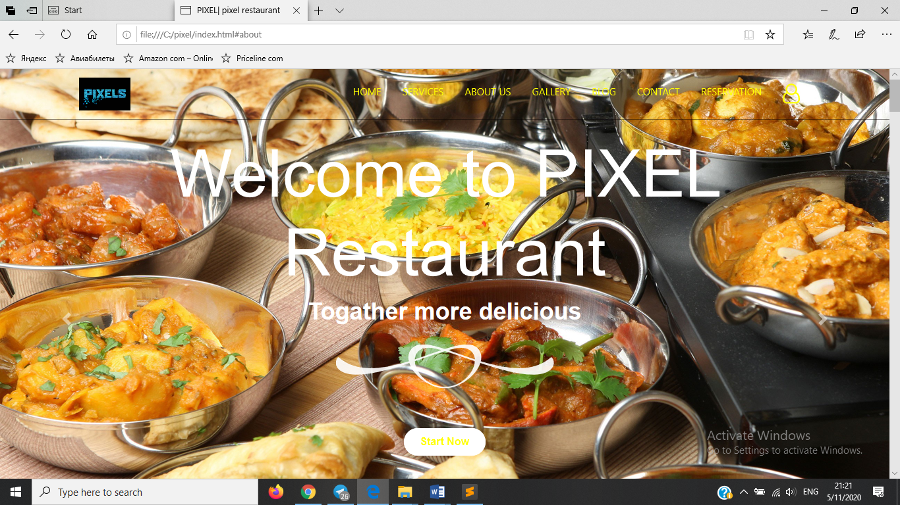

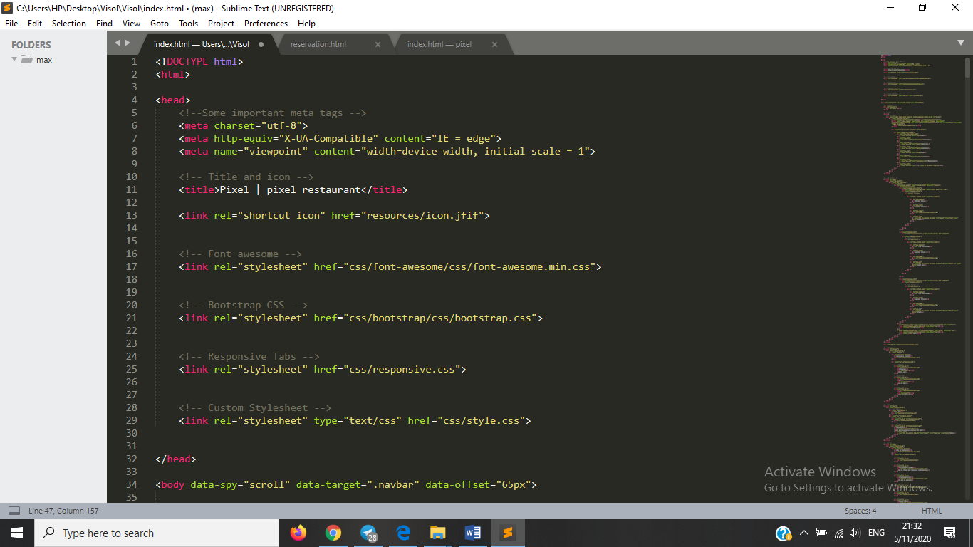

**We have 7 options which are :**

**Services : In Service opion you can see our services , Delivering, Booking and others**

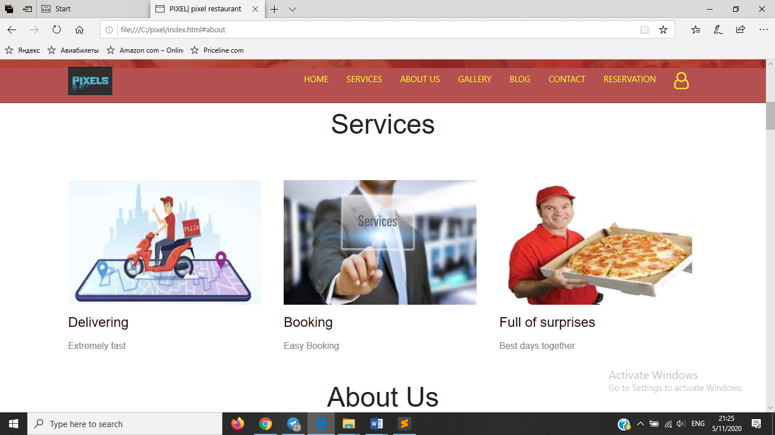

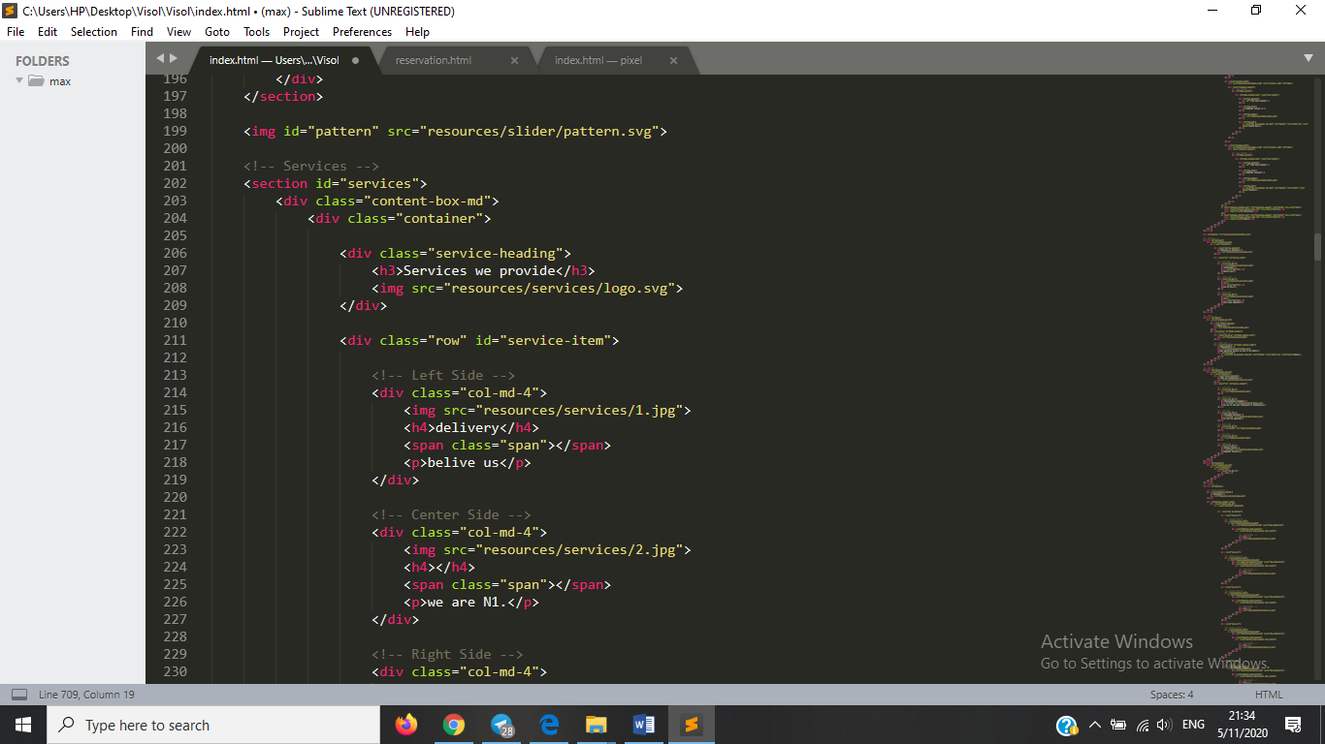

**About Us: there you can see brief information about Restaurant.**

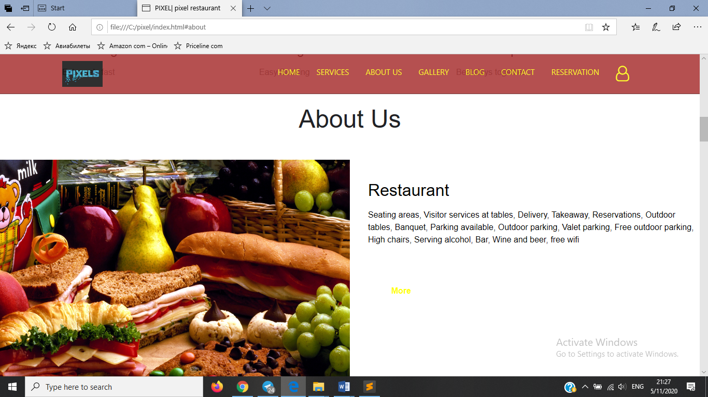

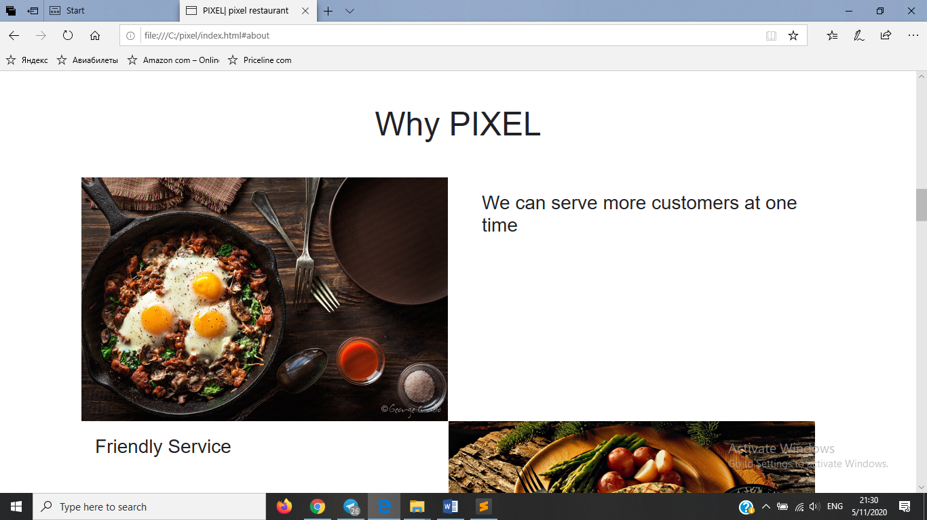

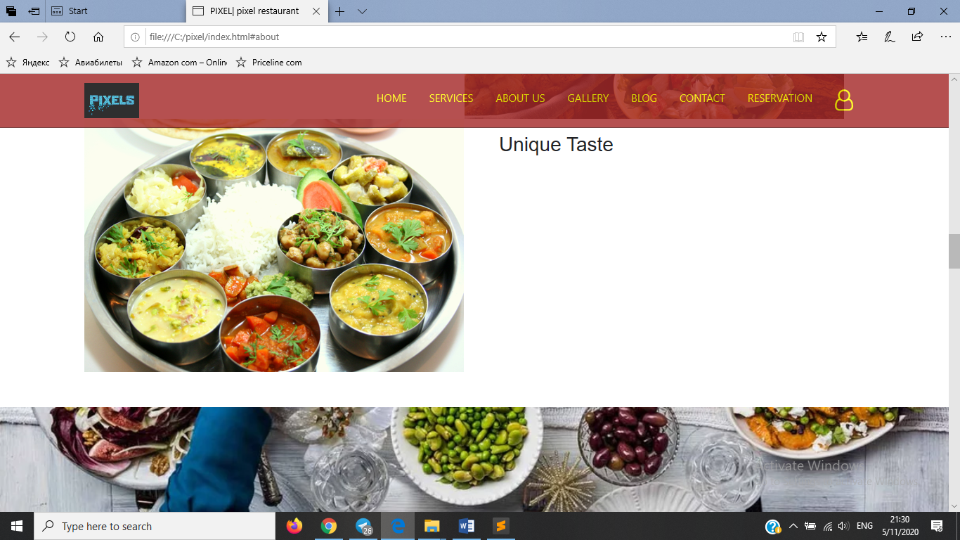

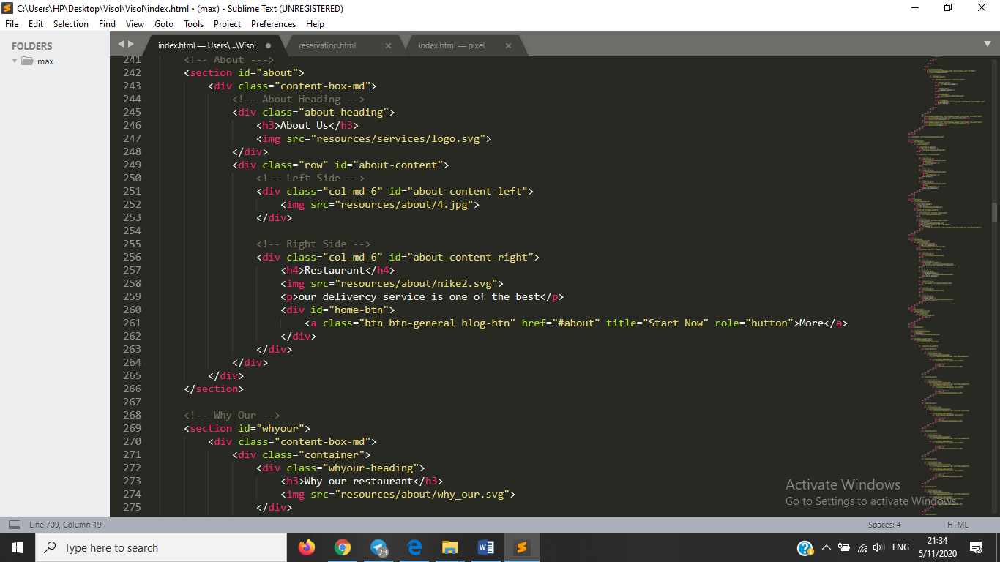

**In Gallery** option there are several meals which you can book or order

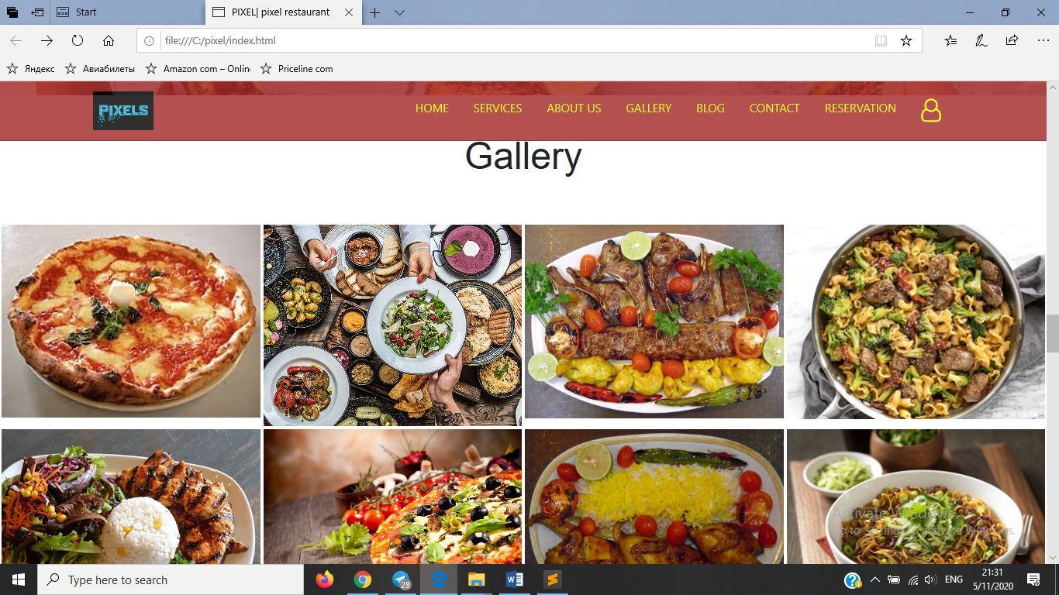

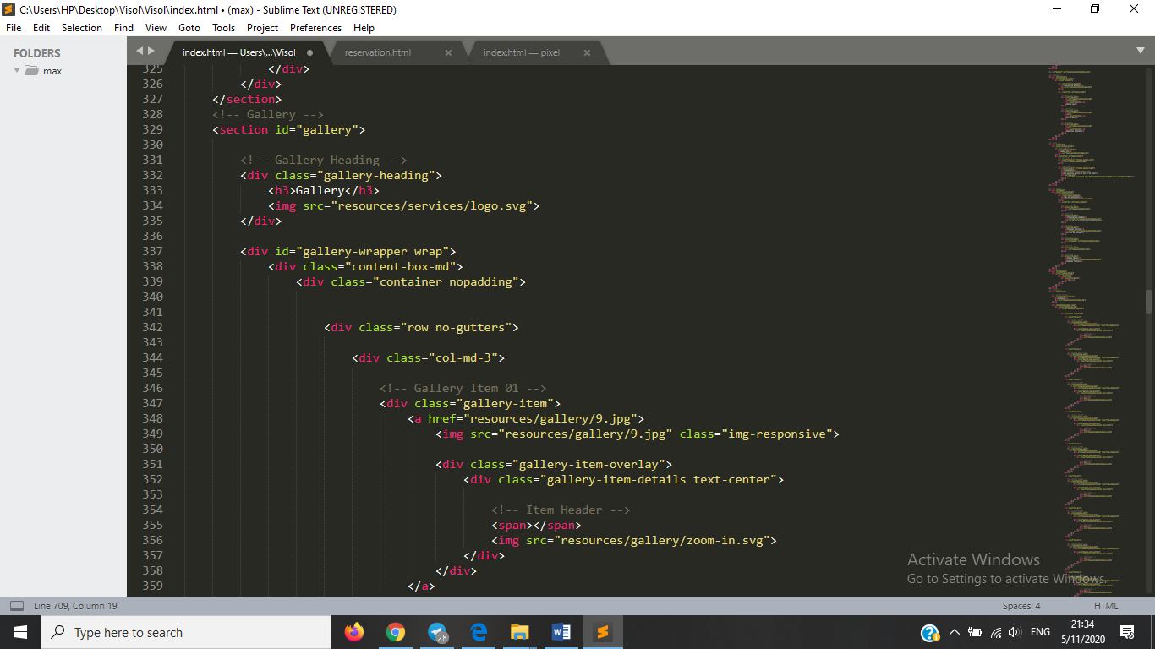

**In blog** section you can see our monthly blog

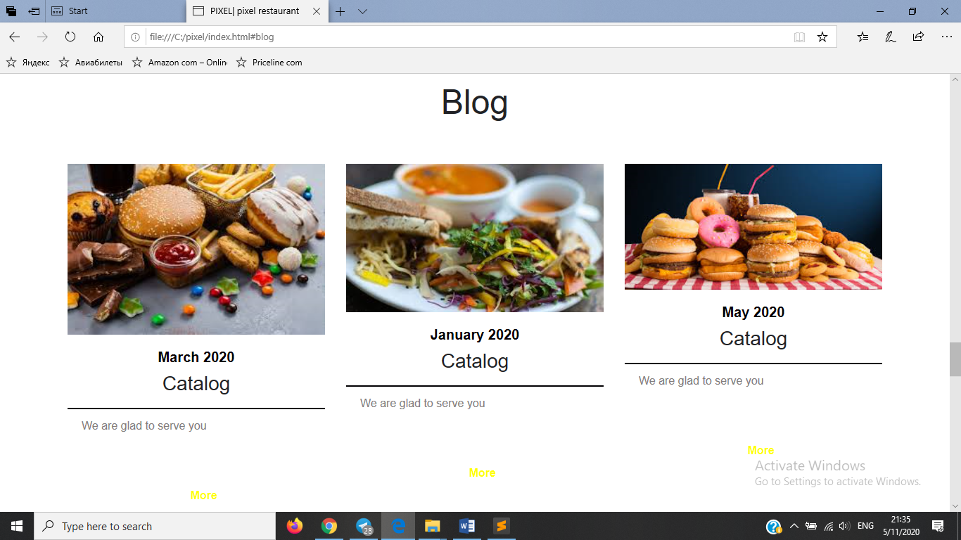 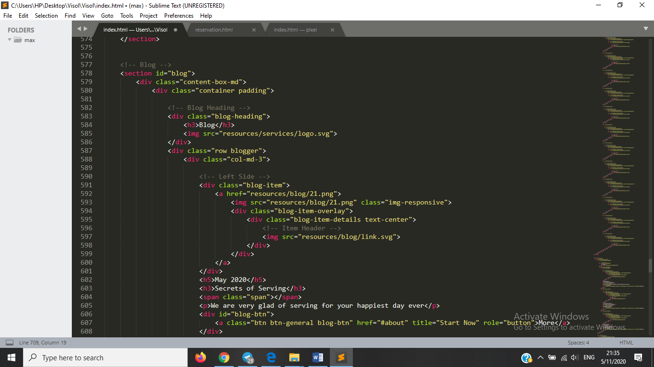

**Contacts:** we tried to put map location as well.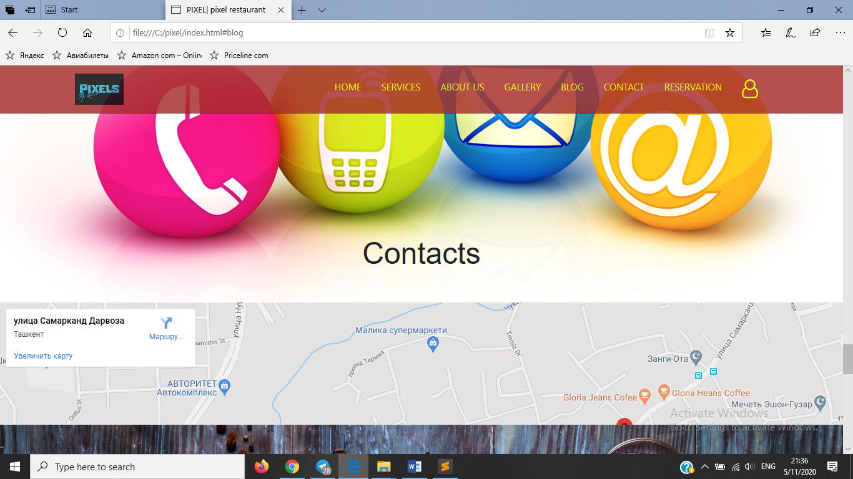

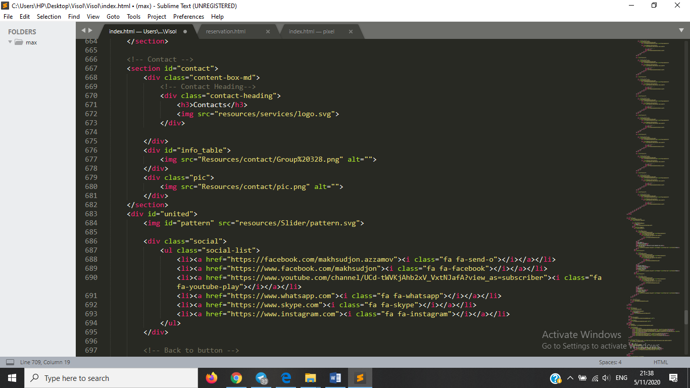

**Finaly we have Reservation page**

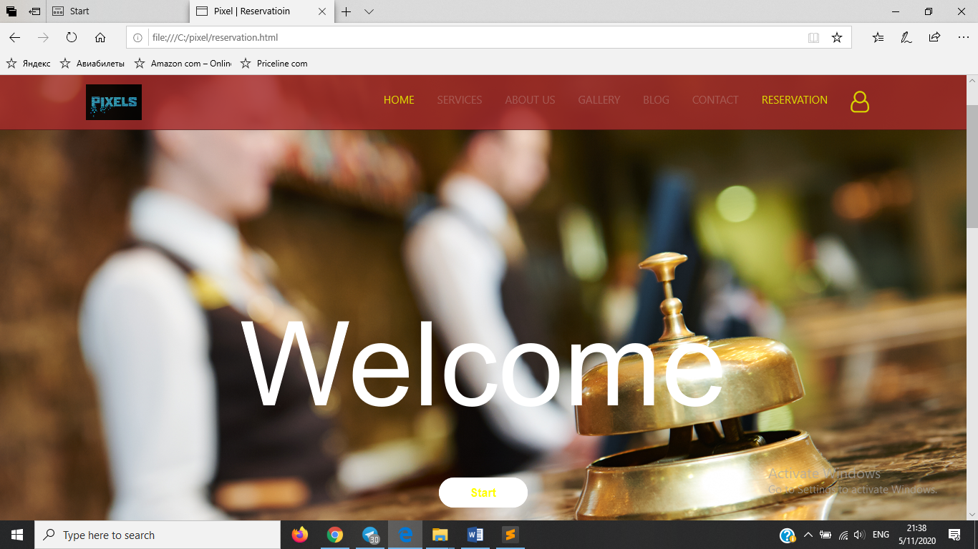

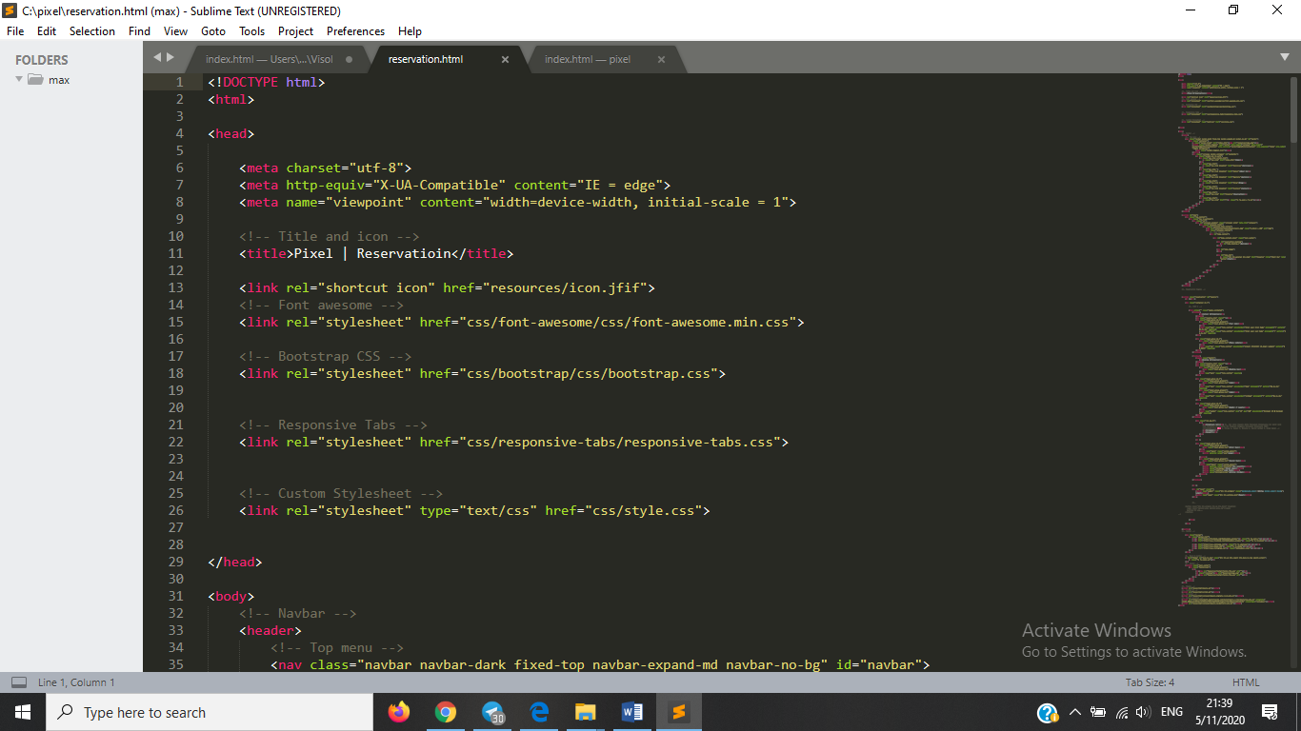

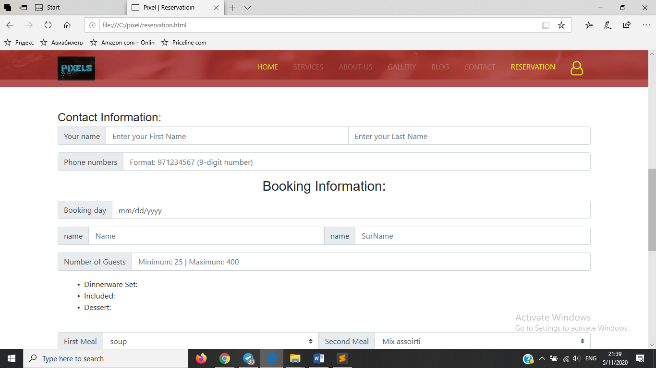

**We tried to create Contact information, so it contains your name, surname, phone number and others.**

**Javlonkhon Egamberdiev** -made page design and dashboard pages and all design and photos

**Ergashjonova Shakhzoda** –made homepage

**Karomatova Shakhrizoda** –made Reservation page

**Sardorjon Oblakulov and Abdulloev Saidjon** with styling these pages. Constructs the page using bootstrap styles and own styles.

**Makhsudjon Azzamov** – worked js and jquery.js